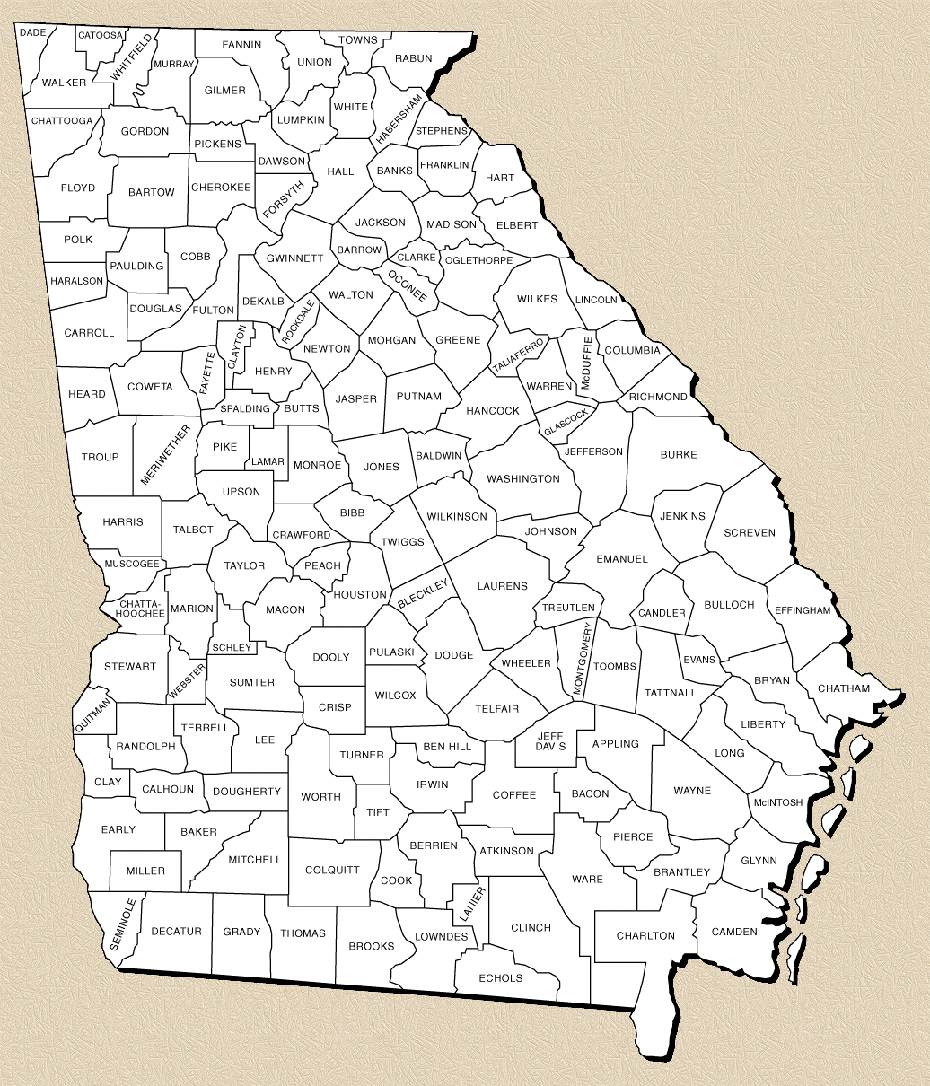

The Georgia Dept. of Agriculture has scheduled a one-day Pesticide Waste Clean Day Event for **August 16, 2023**. The event will be held in Coffee County at the Tri-County Gin located at 561 Sinkhole Rd. Douglas, Ga. 31535 from 9:00am to 3:00pm. Due to limited funding the event will require pre-registration for more information contact **Rick Hayes 404-535-1614**

Georgia Clean Day Event 2023